**CLECKSHOPHUB**

**TEAM 4**

**Use Case Diagram**

**Team Members**

Abhishek Poudel

Amulya Shrestha

Biliyas Maharjan

Biraj Shrestha

Shasank Shrestha

Soya Shrestha

Sushan Bhandari

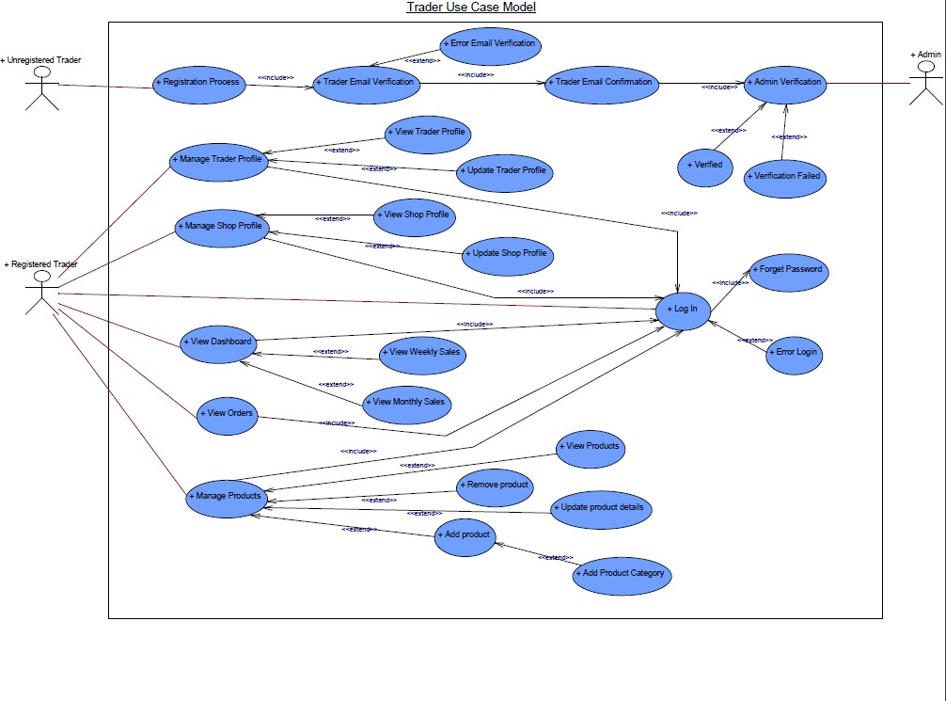

FIG1: Trader Use Case Diagram

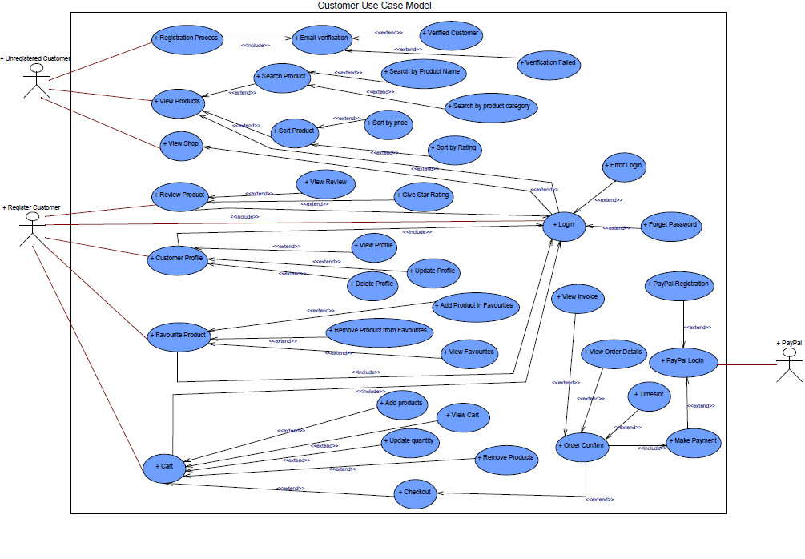

FIG2: Customer Use Case Diagram

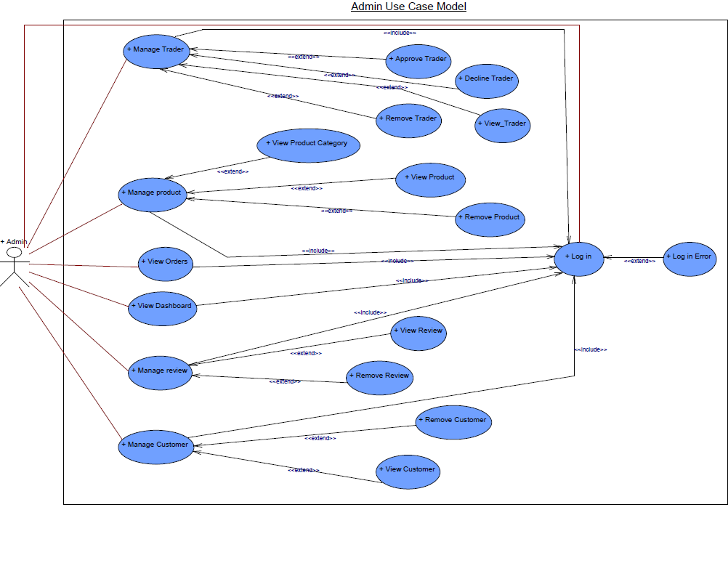FIG3: Admin Use Case Diagram

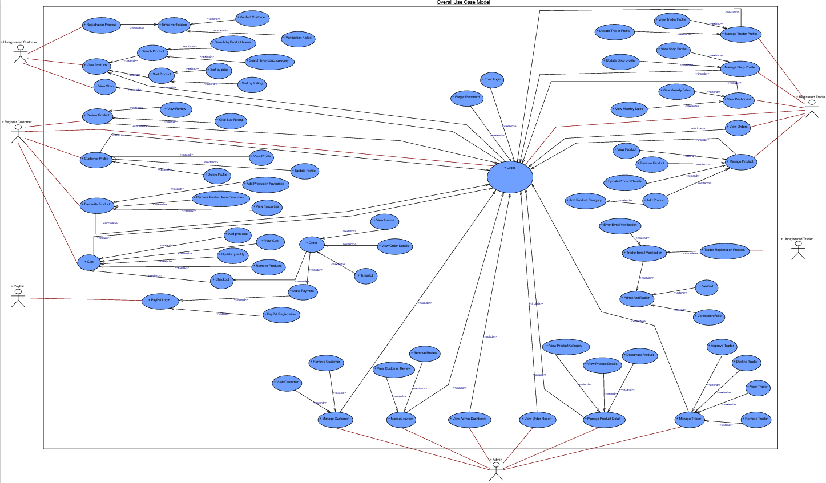

FIG4: Overall Use Case Diagram